31 Ağu 2021

MATPLOTLIB

# **Introductory(Image tutorial)**

1. **Np arraylerini resim olarak grafkleştirme**

[imgplot](https://matplotlib.org/stable/api/image_api.html#matplotlib.image.AxesImage) = [plt.imshow](https://matplotlib.org/stable/api/_as_gen/matplotlib.pyplot.imshow.html#matplotlib.pyplot.imshow)(img)# Np arrayi olarak yüklenilmiş resmi grafiğe dökeriz.

1. **Psuedo şema ekleme**

* [plt.imshow](https://matplotlib.org/stable/api/_as_gen/matplotlib.pyplot.imshow.html#matplotlib.pyplot.imshow)([lum_img](https://docs.scipy.org/doc/numpy/reference/generated/numpy.ndarray.html#numpy.ndarray), cmap="hot") # Colormap kullanılarak şemalar eklenebilir
* [imgplot](https://matplotlib.org/stable/api/image_api.html#matplotlib.image.AxesImage) = [plt.imshow](https://matplotlib.org/stable/api/_as_gen/matplotlib.pyplot.imshow.html#matplotlib.pyplot.imshow)([lum_img](https://docs.scipy.org/doc/numpy/reference/generated/numpy.ndarray.html#numpy.ndarray))

[imgplot.set_cmap](https://matplotlib.org/stable/api/cm_api.html#matplotlib.cm.ScalarMappable.set_cmap)('nipy_spectral') # setter methodlar kullanılarak da colormap eklenebilir.

1. **Renk skalası ekleme**

* [imgplot](https://matplotlib.org/stable/api/image_api.html#matplotlib.image.AxesImage) = [plt.imshow](https://matplotlib.org/stable/api/_as_gen/matplotlib.pyplot.imshow.html#matplotlib.pyplot.imshow)([lum_img](https://docs.scipy.org/doc/numpy/reference/generated/numpy.ndarray.html#numpy.ndarray))

[plt.colorbar](https://matplotlib.org/stable/api/_as_gen/matplotlib.pyplot.colorbar.html#matplotlib.pyplot.colorbar)()

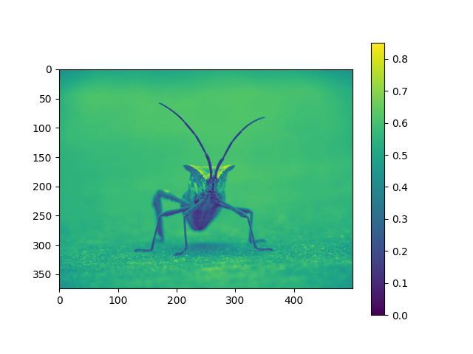

Referanslar:

https://matplotlib.org/stable/tutorials/introductory/images.html#sphx-glr-tutorials-introductory-images-py